**Green Society Public School**

**D-08**

**Ratnanagar-7, Sauraha, Chitwan**

**Second Terminal Examination-2082**

**Class: One Time: - 1 hr. F.M.: 25**

**Sub: Science**

|  |
| --- |
| **Name: Roll No.: Sec.:** |
| **­­­­­­­­­­­­ ________________ ______________ OBT.MARKS:**  **INVIGILATOR EXAMINER** |

1. **Write True and False. (4)**

a) Plants and animals are friends.

b) An elephant is small animal.

c) Farmers care patients in hospitals.

d) Caring animals and plants are good habits.

1. **Fill in the blanks by choosing correct words. (3)**

**(safe, flesh, bad)**

1. Broken bottles are not _____________.
2. Playing with dirty things is a __________ habit.
3. Lion is a _________ eating animal.
4. **Match the following. (4)**

Bird Rice, wheat, corn

Food grains Flesh eating animal

Tiger Insects

Frog. Nest

1. **Read the given information and identify who am I. (2)**
2. I live in water. I have fins and tail_____________.
3. People color me black and white on the road. They cross road through me__________________________________.
4. 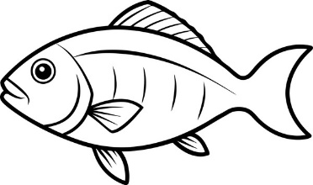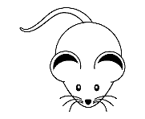**Name the following pictures. (6)**

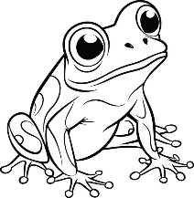

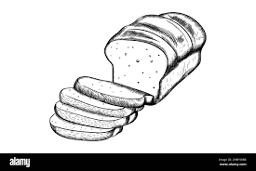

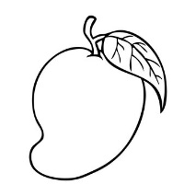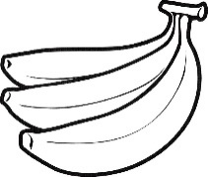

1. **Answer the following questions. (6)**
2. Where do plants get water from?

Ans:- __________________________________________________________________.

1. Is caring plants and animals a good habit?

Ans:-__________________________________________________________________.

1. How can we be healthy?

Ans:-__________________________________________________________________.

**The End**